**CAPSTONE PROJECT**

**CINEFLOW MODERN VIEWER**

**A PROJECT REPORT**

***Submitted by***

KRISHNA SUBRAMANIAN [192211042]

*Under the guidance of*

**Dr. M Kathiravan**

***in partial fulfilment for the completion of course CSA4399- INTERNET***

***PROGRAMMING FOR CLIENT SERVER COMPUTING***

**SIMATS ENGINEERING**

**THANDALAM**



**SEPTEMBER 2024**

**DECLARATION**

**Krishna Subramanian,** student of **Bachelor of Engineering in Computer Science**, Department of Computer Science and Engineering, Saveetha Institute of Medical and Technical Sciences, Saveetha University, Chennai, hereby declare that the work presented in this Capstone Project Work entitled **“CINEFLOW MODERN VIEWER”** is the outcome of my own Bonafede work and is correct to the best of our knowledge and this work has been undertaken taking care of Engineering Ethics.

**Krishna Subramanian (192211042)**

**BONAFIDECERTIFICATE**

Certified that this project report titled **“CINEFLOW MODERN VIEWER** is the Bonafede work of **“KRISHNA SUBRAMANIAN [192211042]** Student of **Bachelor of Engineering in Computer Science,** Saveetha institute of Medical and Technical Sciences, Chennai, who carried out the project work under my supervision as a batch. Certified further, that to the best of my knowledge the work reported herein does not form any other project report.

**Date: Project supervisor Head of the Department**

**TABLE OF CONTENTS**

|  |  |
| --- | --- |
| **S.NO** | **TOPICS** |
| **1.** | **Introduction** |
| **2.** | **Abstract** |
| **3.** | **Problem Description**  Program to Build a simple software for Cineflow |
| **4.** | **Materials and Methods**  User Interface  Features |
| **5.** | **Approach/Module Description/Functionalities** |
| **6.** | **Implementation** Coding |
| **7.** | **Output** |
| **8.** | **Conclusion**  Future Enhancement  **References** |

**INTRODUCTION**

The rise of on-demand streaming platforms like Netflix and Hulu has transformed the way users consume media content. The availability of personalized recommendations, user-friendly interfaces, and secure payment methods has raised the bar for developing a new media platform. **CineFlow Modern Viewer** was conceptualized as a solution that focuses on providing a streamlined user experience by incorporating features such as a content library, watchlists, and secure subscription management.

As more users shift to online streaming services, it is essential for a platform to provide a secure and intuitive interface. **CineFlow Modern Viewer** addresses these needs by offering a modular approach with secure registration, smooth navigation, and efficient subscription handling.

**ABSTRACT**

**CineFlow Modern Viewer** is a streaming platform designed to offer users a personalized experience for consuming media content. This platform integrates several key features such as user authentication, a content library with reviews and watchlists, and subscription management. The primary technologies used to build the platform are **React.js** for the front end, **Node.js** with **Express** for the back end, and **MySQL** as the database management system. The project is developed using **VS Code** as the main development environment and deployed on **AWS**. The aim is to provide a secure, scalable, and user-friendly solution for media consumption.

**AIM**

The aim of the **CineFlow Modern Viewer** project is to develop a modern and user-friendly streaming platform that enables users to:

* **Register and log in securely** with email-based authentication.
* **Browse and review content** such as movies and TV shows.
* **Add content to a personalized watchlist** for future viewing.
* **Manage subscription plans and make payments** via integrated payment systems.
* Provide an **intuitive and responsive interface** compatible with various devices.

The platform will also ensure secure data transmission using **SSL/TLS encryption** and offer real-time notifications for subscription updates or new content releases.

**MATERIALS REQUIRED**

To build the **CineFlow Modern Viewer** project, the following materials and technologies were utilized:

**1.1 VS Code**

**Visual Studio Code (VS Code)** was the primary integrated development environment (IDE) used to write, debug, and execute the code for the project. It allows seamless integration with a variety of tools and extensions, making it ideal for developing full-stack applications.

**CINEFLOW**

CineFlow is a modular web-based application that provides users with a streamlined content viewing experience. It combines functionalities such as account management, watchlists, and subscription handling. Users can browse through a library of movies and TV shows, leave reviews, manage their subscriptions, and securely handle payments.

**METHODOLOGY**

The methodology adopted for the development of **CineFlow Modern Viewer** follows a **waterfall approach** with clearly defined stages. Each stage was carried out sequentially, ensuring that the project met all technical and functional requirements. The following stages were followed:

1. **Requirement Analysis**: Detailed discussions were held to define the user requirements and the scope of the project.
2. **System Design**: The application’s architecture was designed with a modular approach, allowing for easy scalability.
3. **Development**: The front end was developed using **React.js**, and the back end was implemented with **Node.js** and **Express**.
4. **Database Integration**: **MySQL** was chosen as the database system for managing user data, content metadata, reviews, and subscriptions.
5. **Testing**: Extensive testing was conducted to ensure that all functionalities worked as expected.
6. **Deployment**: The project was deployed on **AWS** with security configurations for SSL/TLS encryption.

**IMPLEMENTATION**

**1.1 Frontend**

The front end of the application was developed using **React.js** to create a dynamic and responsive user interface. The main components of the UI include:

* **Home Page**: Displays featured and trending content based on popularity and user reviews.
* **Login and Registration Forms**: Facilitates user authentication with email verification.
* **Content Library**: Allows users to search for and filter content based on genres and ratings.
* **Watchlist**: Provides users with the ability to save movies or shows they wish to watch later.
* **Subscription Page**: Displays current subscription plans and allows users to manage their accounts.

**1.2 Backend**

The back end was implemented using **Node.js** and **Express**, providing an API to manage user requests. The server interacts with the front end and the database to handle functionalities such as:

* **User Authentication**: Implemented with **JWT (JSON Web Tokens)** to ensure secure user sessions.
* **Data Storage**: **MySQL** was used to manage user profiles, movie metadata, reviews, and subscription information.
* **Subscription Management**: Integration with the **Stripe API** allowed for seamless handling of payments and subscription updates.

**1.3 Database**

The **MySQL** database schema includes tables for users, movies, reviews, watchlists, and subscriptions. The database was optimized with indexes to ensure fast retrieval of data, particularly for personalized user experiences like watchlists and content recommendations.

**1.4 Deployment**

**AWS** was used to host the platform. The deployment included:

* **SSL/TLS encryption** for secure data transmission.
* **Elastic Load Balancing** to manage traffic during high-load periods.
* **Auto-scaling** to handle increased user activity during peak times.

**User Interface Description**

The **CineFlow Modern Viewer** platform was designed to provide a seamless and intuitive user experience. The key pages and elements of the UI include:

**1.1 Home Page**

The home page is the main entry point for users. It displays trending movies, recommendations, and new releases. Users can scroll through featured content and access the content library.

**1.2 Content Library**

The content library allows users to browse through movies and TV shows. It includes options to filter content based on:

* **Genre**
* **Release Date**
* **Average Rating**

Each content item provides a brief description, along with the option to add the movie or show to the user’s watchlist.

**1.3 Watchlist**

Users can add content to their watchlist for later viewing. This watchlist is easily accessible from the user’s dashboard.

**1.4 Subscription Page**

The subscription page allows users to view their current plan and select from various pricing tiers. The **Stripe API** integration enables secure payment management.

**1.5 Profile Management**

Users can update their personal information, change passwords, and review their content activity history. This section also includes features like password recovery and email updates.

**MODULE DESCRIPTION**

The platform was developed using a modular architecture. Each module is independent and performs a specific set of tasks.

**1.1 Authentication Module**

This module handles user registration, login, and password recovery. It uses **JWT tokens** to securely manage user sessions and ensure only authorized access to specific content.

**1.2 Content Management Module**

This module displays the available movies and TV shows. It allows users to browse through the content library, view details, add ratings, and leave reviews. The module also manages the watchlist functionality.

**1.3 Subscription Module**

This module manages all subscription-related tasks. Users can view, update, or cancel their subscriptions. Integration with the **Stripe API** ensures secure payment handling.

**1.4 Review and Rating Module**

This module allows users to leave ratings and reviews for the movies and TV shows they have watched. The average ratings are displayed for all users to see.

**1.5 Support and Notifications Module**

Users receive notifications for important updates such as system maintenance, new content, or subscription reminders. A support system is available to provide technical assistance.

**FUNCTIONALITIES**

The **CineFlow Modern Viewer** provides several key functionalities:

* **User Authentication**: Secure user login and registration with email verification.
* **Content Browsing**: Users can browse a library of movies and TV shows.
* **Watchlist Management**: Users can save content to their personalized watchlists.
* **Review and Ratings**: Users can leave reviews and ratings for the content they watch.
* **Subscription Management**: Users can securely manage their subscriptions and payment details.
* **Notifications**: System notifications and reminders for users.
* **Responsive Design**: The platform is fully optimized for both mobile and desktop devices.

**PROCESS**

The development process for **CineFlow Modern Viewer** involved the following steps:

1. **Planning and Requirement Gathering**: Identifying user needs and defining the project scope.
2. **Design and Architecture**: Creating wireframes and defining the system architecture.
3. **Frontend Development**: Using **React.js** to develop the user interface and integrate responsive design elements.
4. **Backend Development**: Implementing the server-side functionality with **Node.js** and **Express**.
5. **Database Setup**: Designing the **MySQL** database and writing SQL queries for content management.
6. **Payment Integration**: Integrating the **Stripe API** for subscription and payment functionalities.
7. **Testing**: Conducting unit tests and user acceptance testing.
8. **Deployment**: Launching the platform on **AWS** with a focus on security and scalability.

**FUTURE SCOPES**

The **CineFlow Modern Viewer** platform has the potential to evolve further by incorporating:

* **AI-based Recommendation System**: Using machine learning algorithms to provide personalized content recommendations.
* **Mobile Application**: Developing native apps for iOS and Android devices.
* **Multi-language Support**: Adding support for multiple languages to cater to a global audience.
* **Social Features**: Integrating social media sharing and the ability for users to create and share playlists.
* **Live Streaming**: Adding support for live events or real-time content streaming.

**OUTPUT**

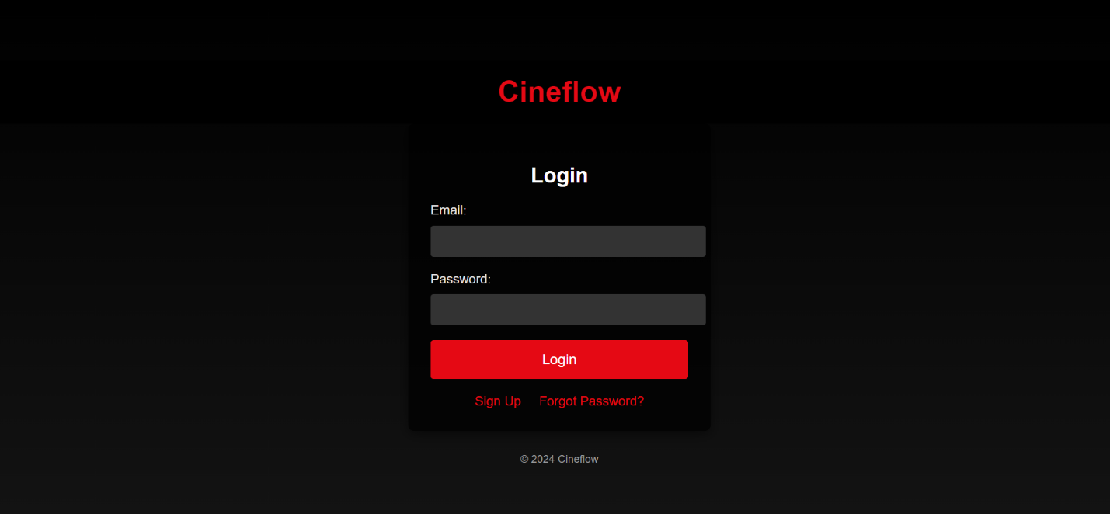

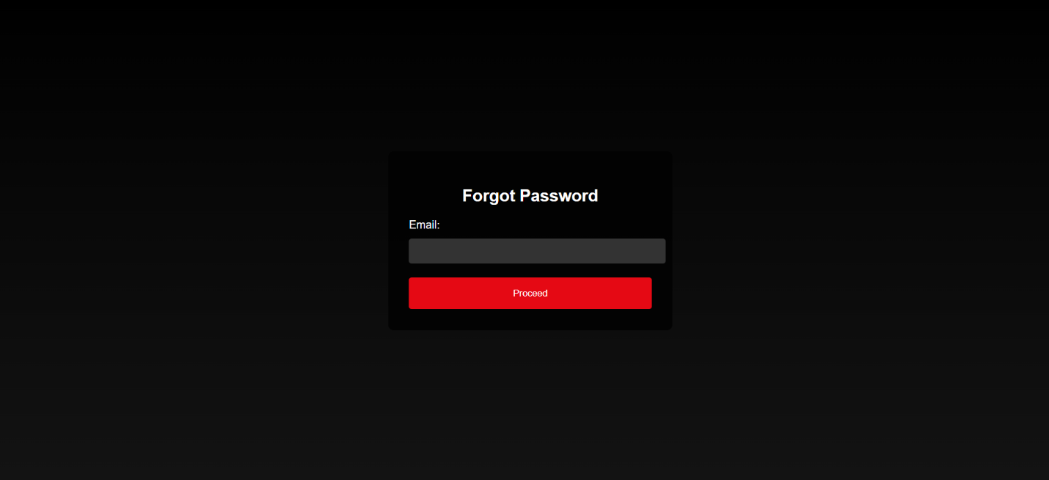

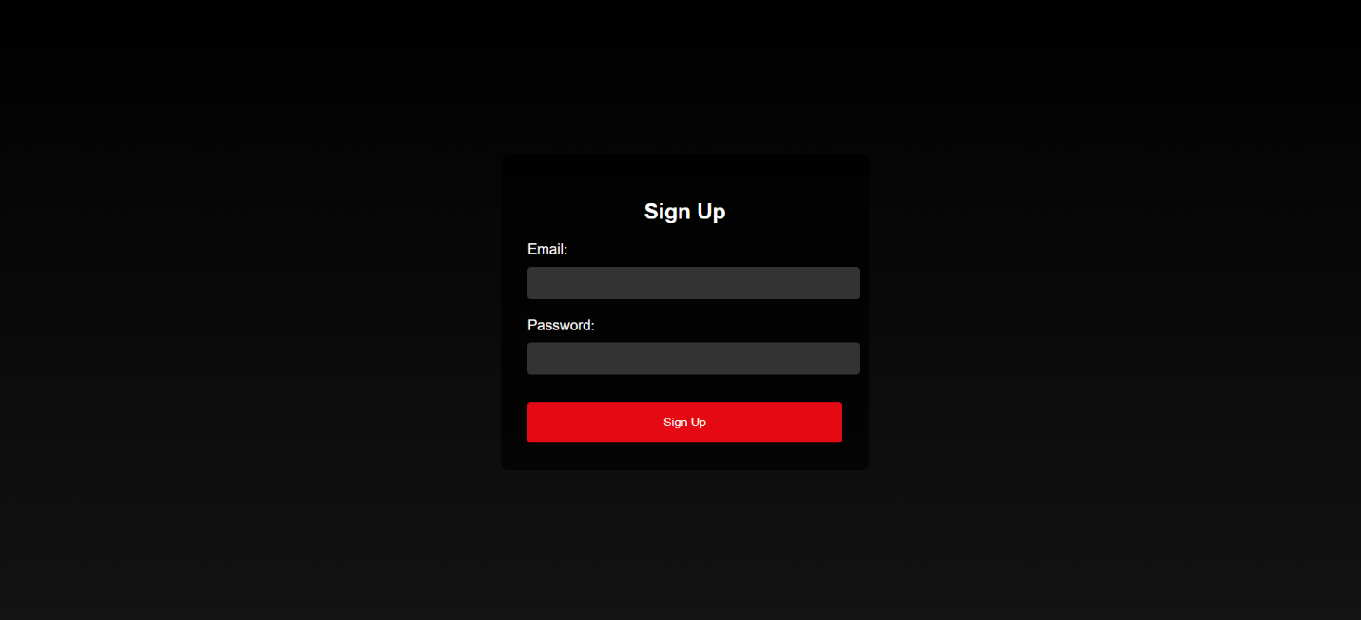

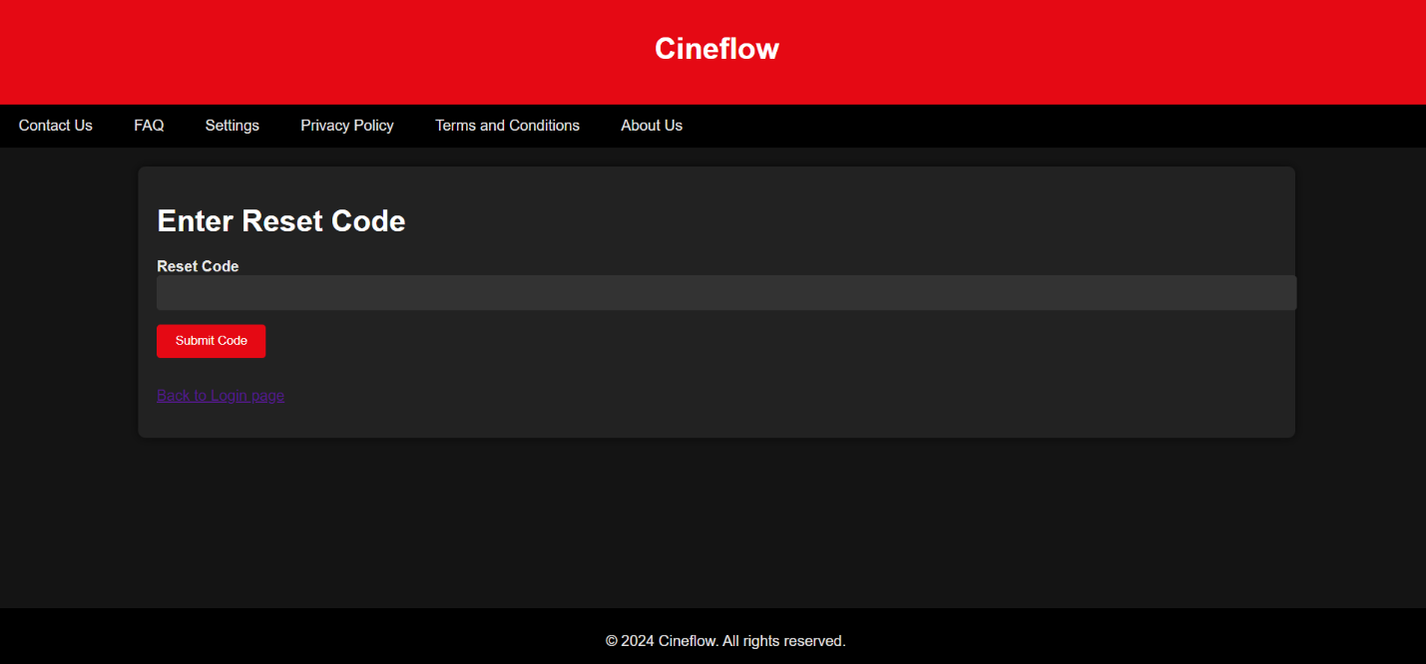

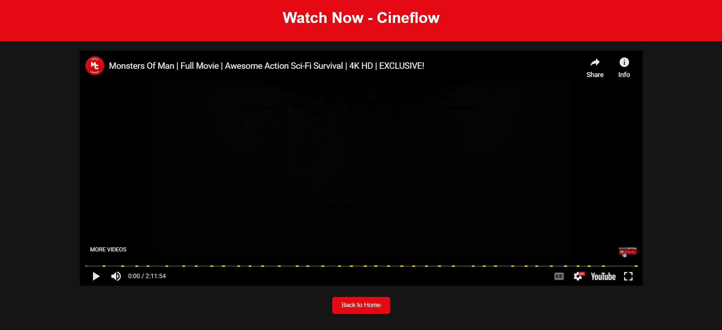

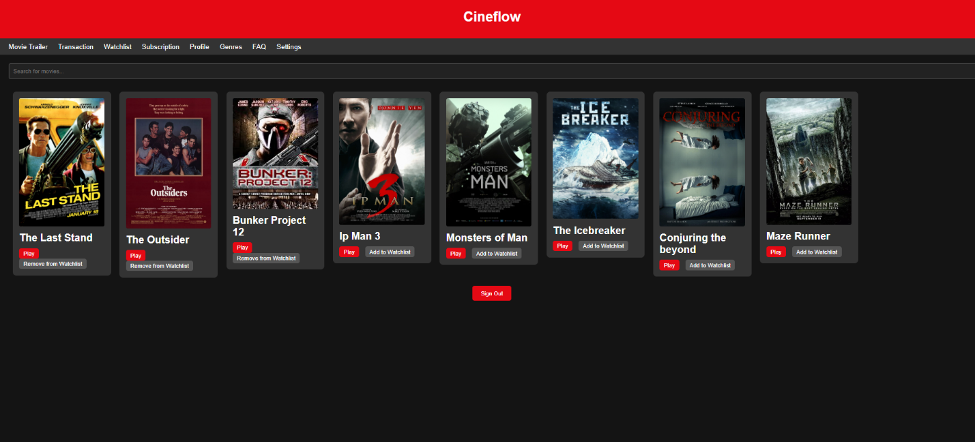

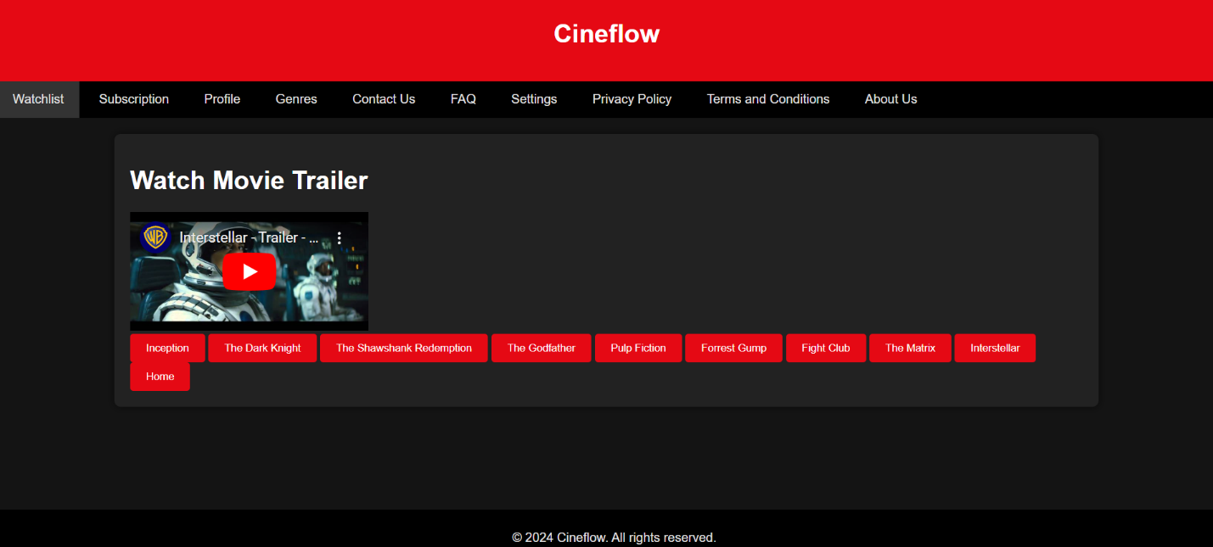

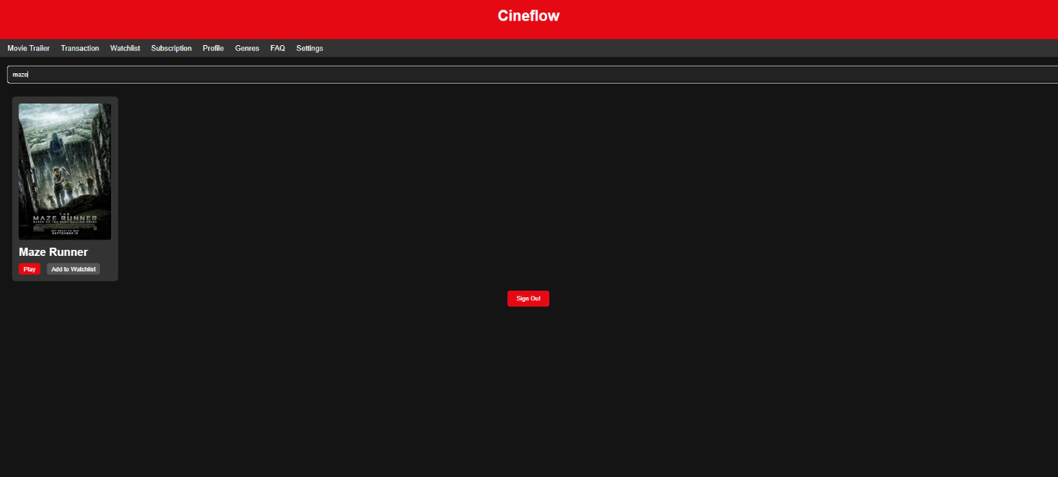

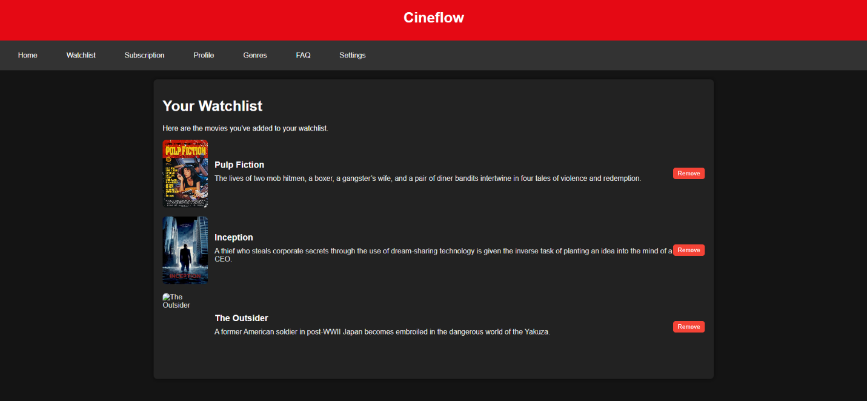

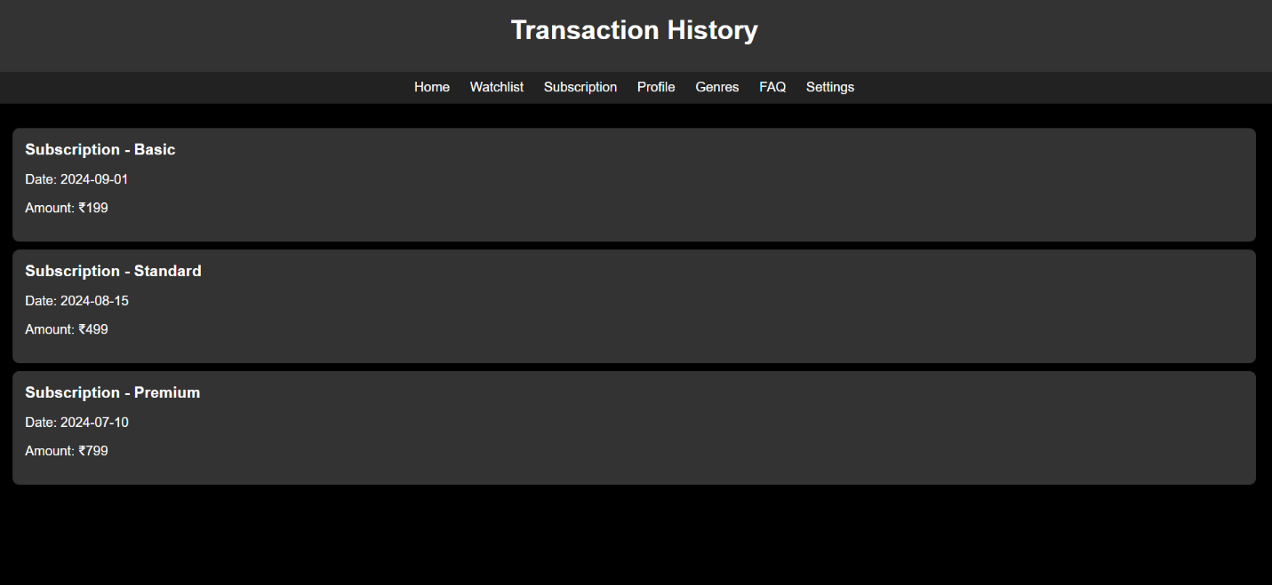

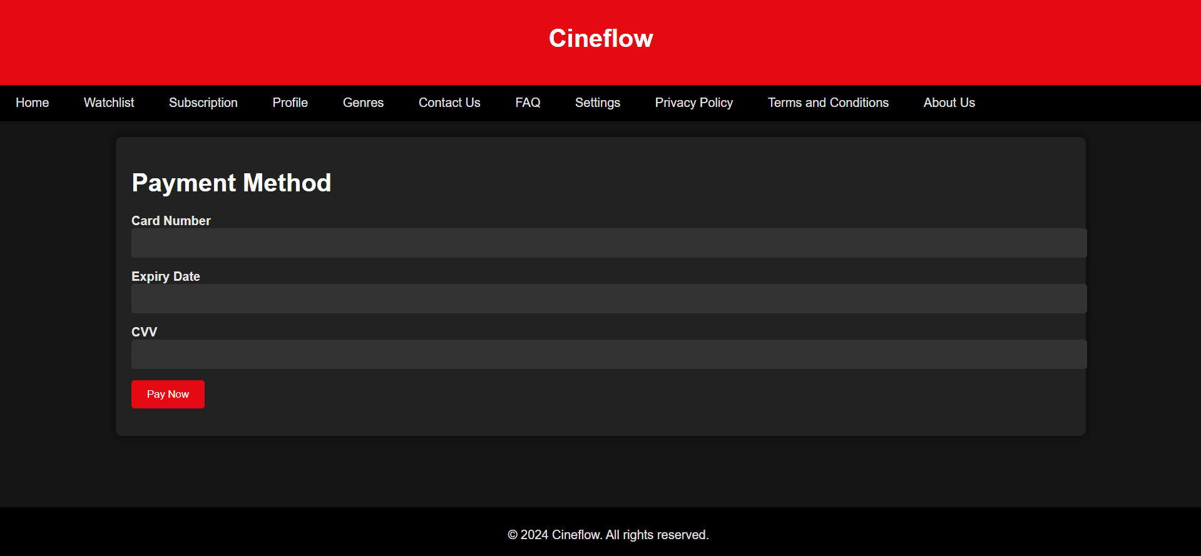

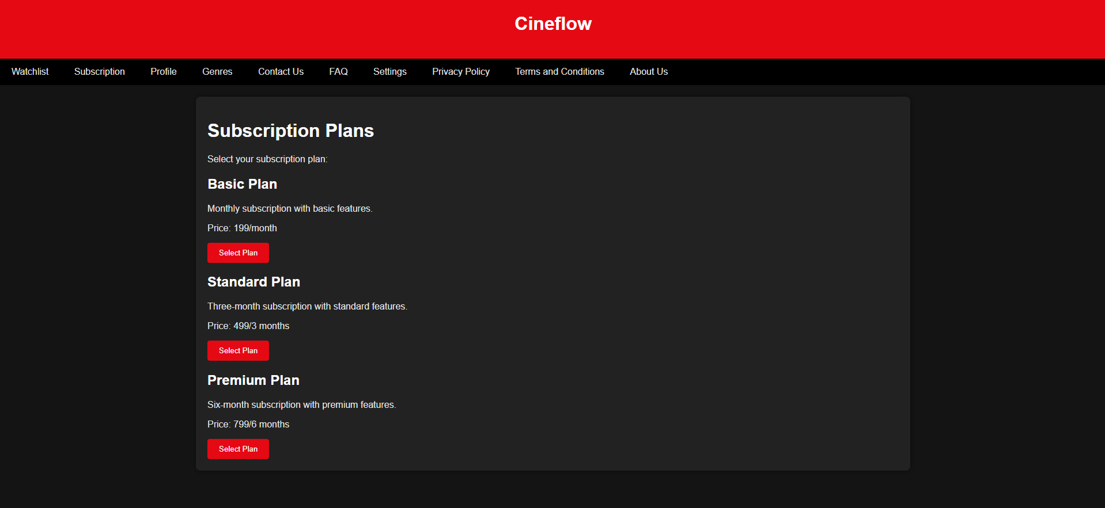

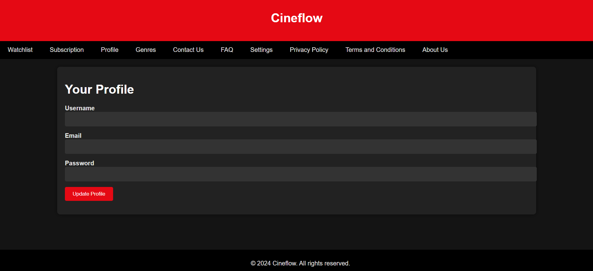

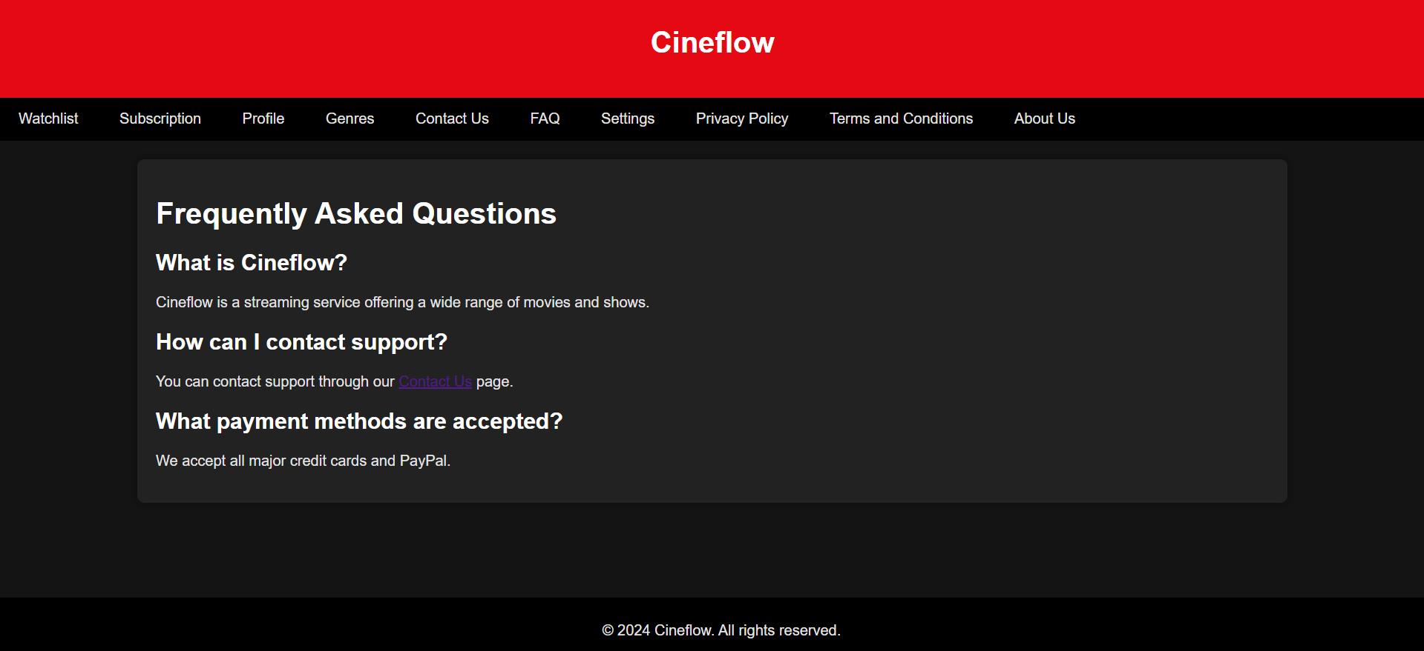

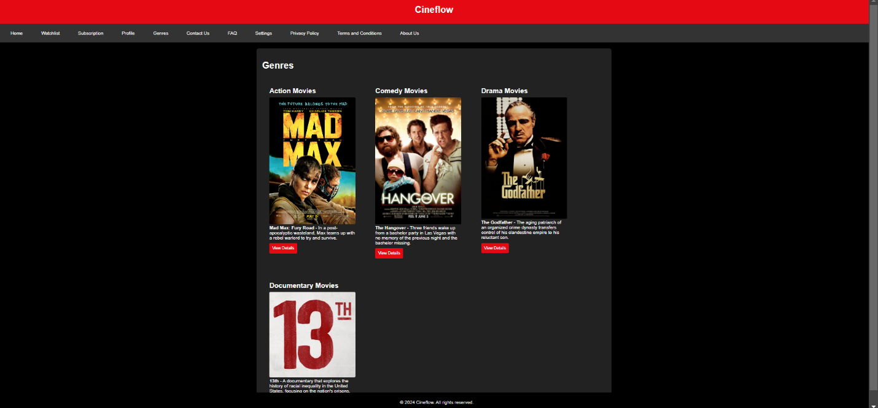

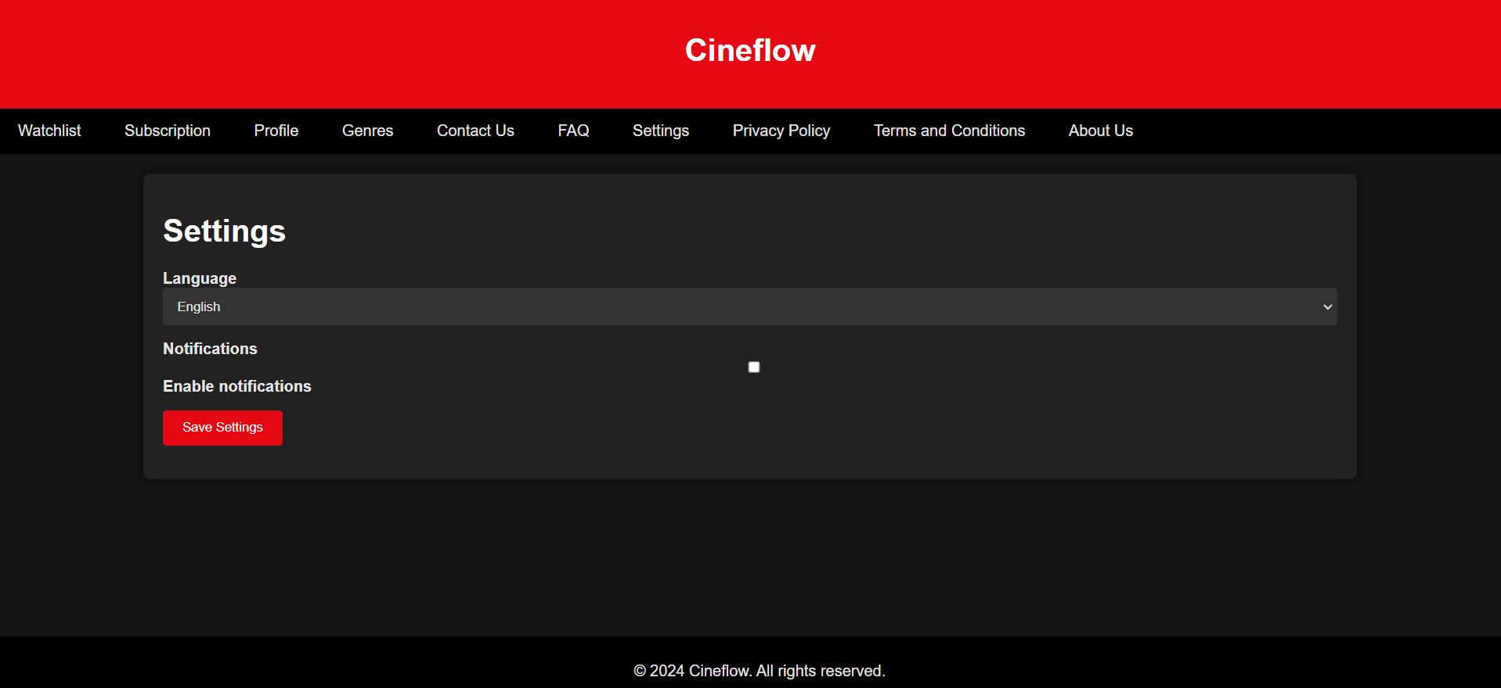

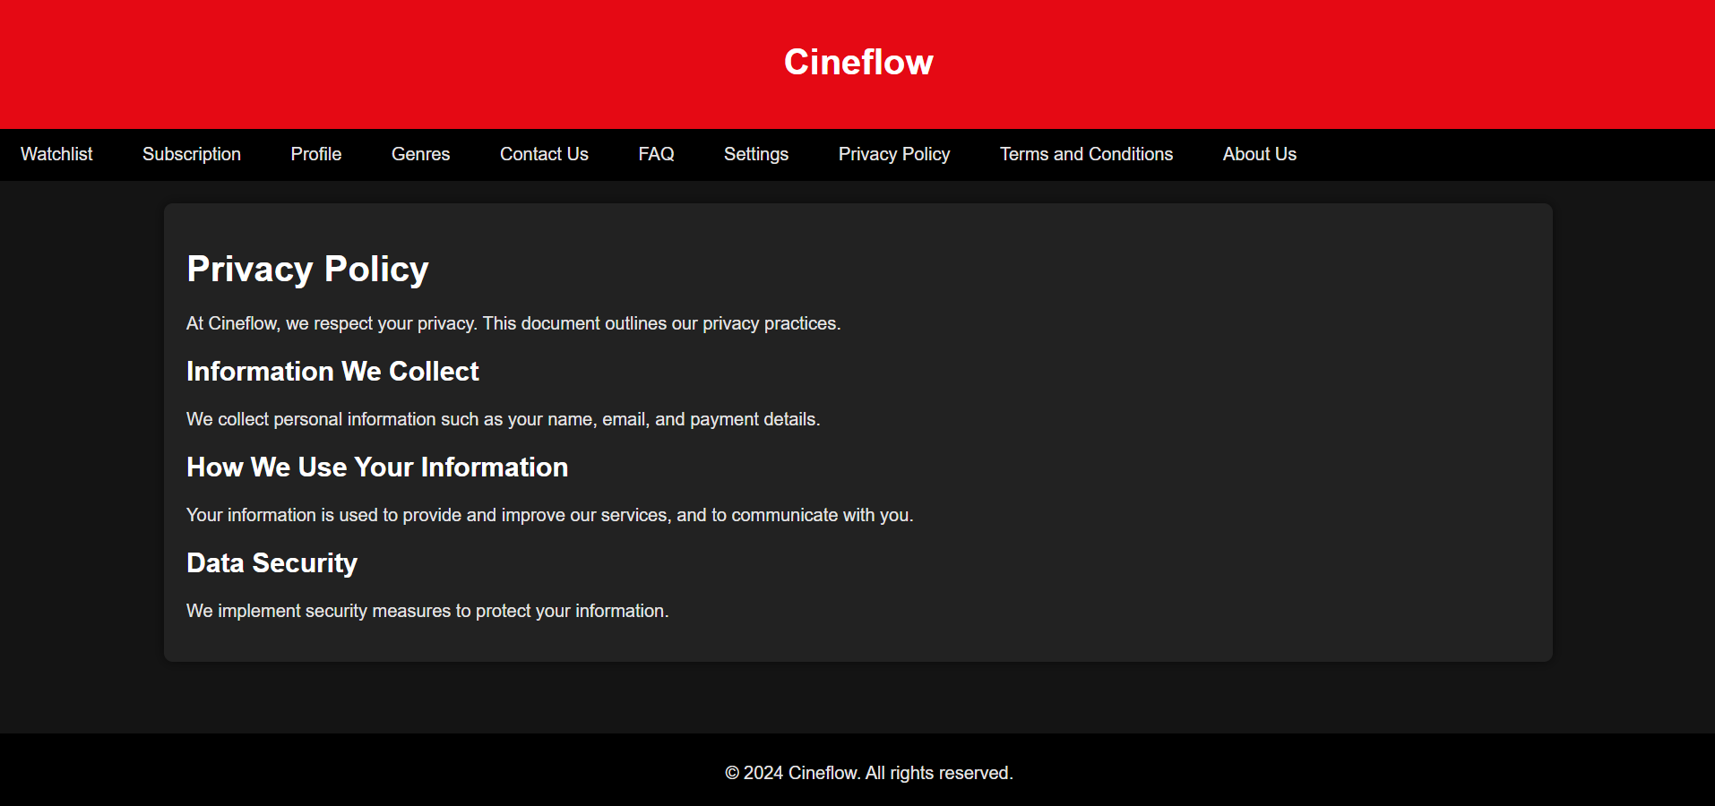

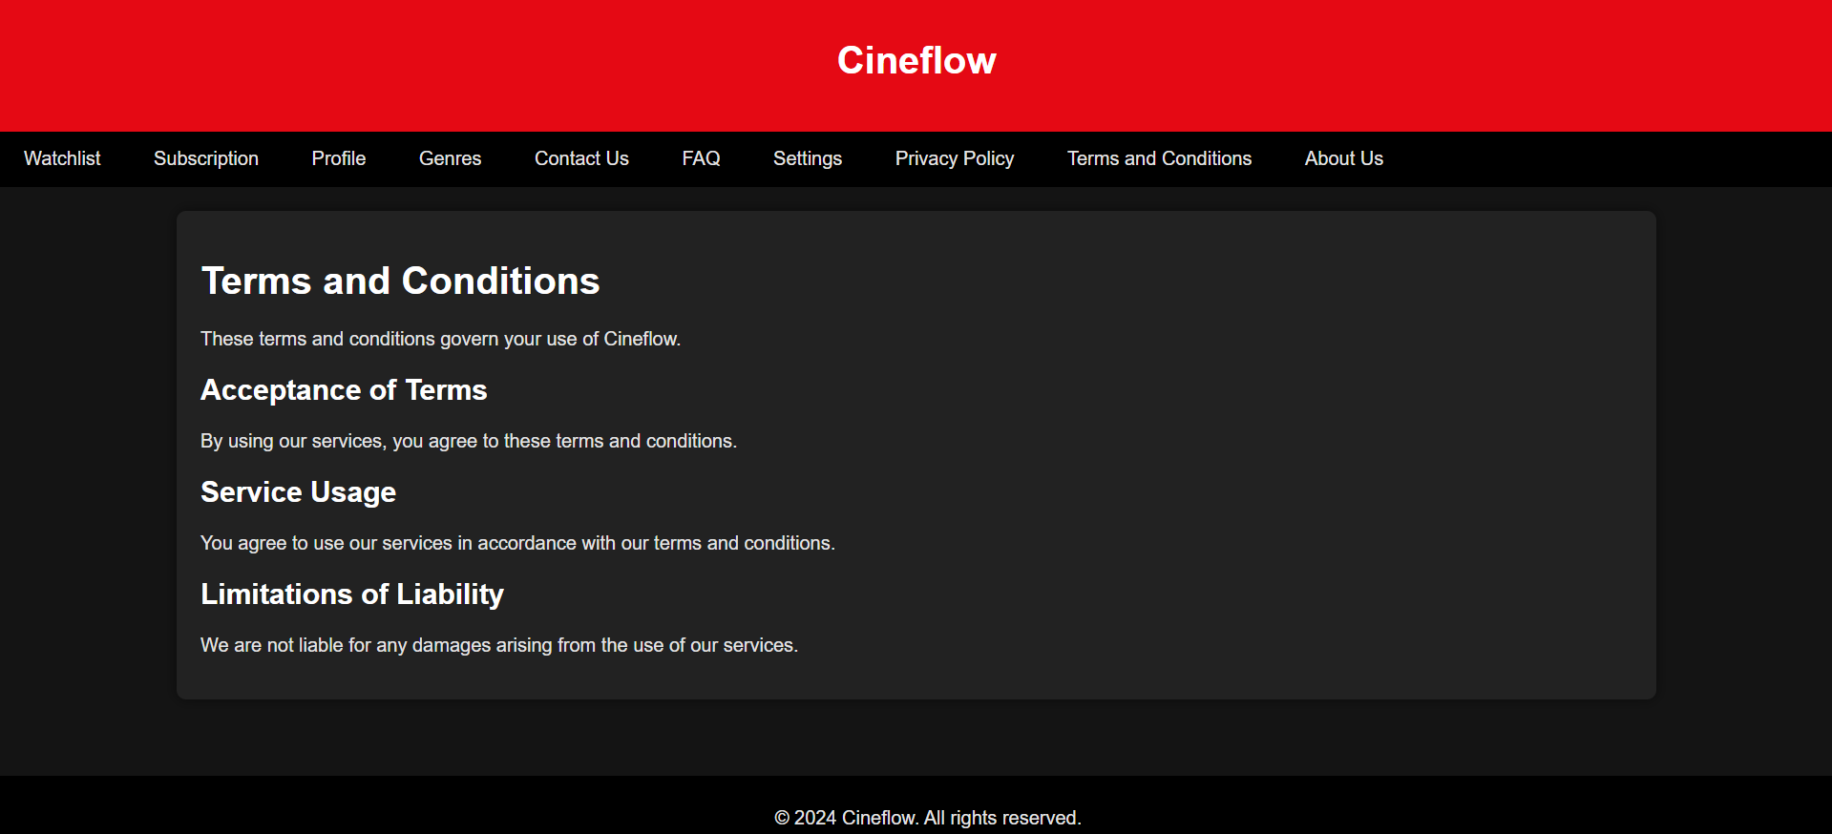

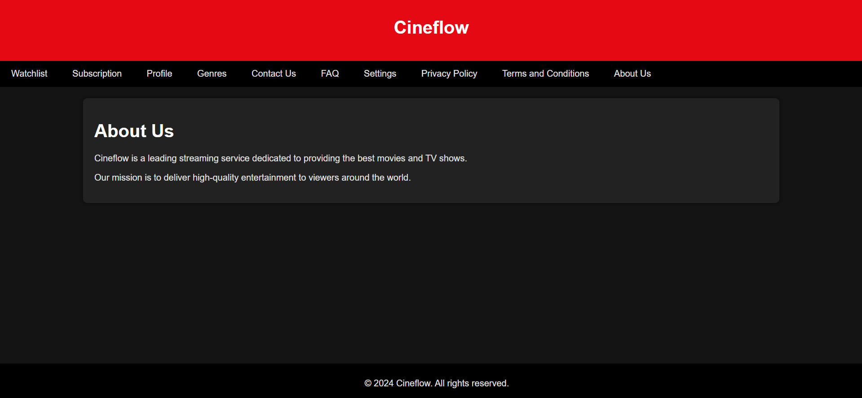

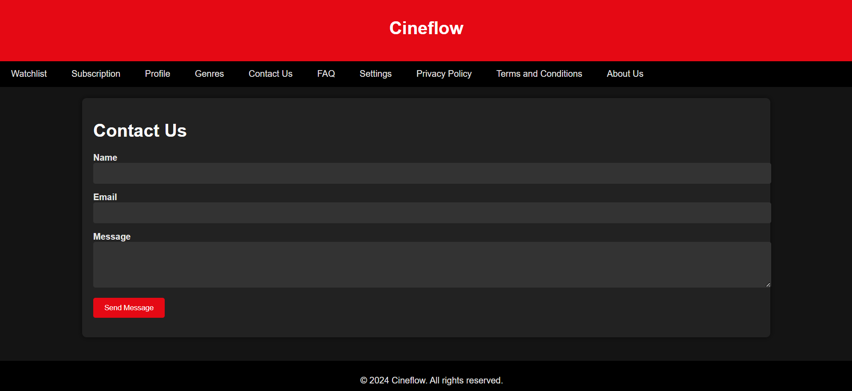

**CONCLUSION**

The **CineFlow Modern Viewer** project successfully delivers a modern streaming platform that addresses the core needs of users. The platform’s intuitive design, secure authentication, and flexible subscription management provide a strong foundation for media consumption. With future enhancements, such as AI-driven recommendations and mobile app integration, the platform can grow into a more comprehensive and scalable solution.

**REFERENCES**

1. W3C. HTML5 Specification. Retrieved from <https://www.w3.org/TR/html5>
2. React.js Documentation. Retrieved from <https://reactjs.org>
3. Node.js Documentation. Retrieved from https://nodejs.org/en/docs/
4. Express.js Guide. Retrieved from https://expressjs.com/en/starter/guide.html
5. MySQL 8.0 Reference Manual. Retrieved from <https://dev.mysql.com/doc/>